Day 1 Lab Assignments <script src="script.js"></script>
Please do these assignments (Use strict mode in all assignments): (Red Text is Bonus)
- On your page, show alert for the user that say “Welcome to my site”, then show him prompt ask him to enter his name and write to the page “ welcome + his name”. (Remark what happen to the home page after writing welcome page).
- Make a function in external JS file, that takes 2 parameters and return sum of them (function return the result, don't alert or print inside it), and make a button that when clicked; asks the user to enter 2 numbers (prompt), call the sum function, and display the result returned by the function in the console.
- Make a function that takes today’s temperature as a parameter, prints: “HOT” if the entered temperature are more than or equals 30 and “Cold” if it’s less than 30 (use ternary conditional operator).
- Change the previous function to take 2 parameters: Temperature and Actual feel temperature to have 3 cases:
  - Prints normal if both of temperature and actualFeel between 25 and 30.
  - Prints Cold if both of temperature and actualFeel less than 25.
  - Prints Hot if both of temperature and actualFeel higher than 30.
  - Prints “Ambiguous, can’t detect”, in any different case.
Can you use ternary conditional operator in previous example? Why?
Can you use switch case in previous example? Why?
- Make a function that takes Student faculty as a parameter, checks:
  - If the entered faculty: FCI, show message: “You’re eligible to Programing tracks”.
  - If the entered faculty: Engineering, show message: “You’re eligible to Network and Embedded tracks”.
  - If the entered faculty: Commerce, show message: “You’re eligible to ERP and Social media tracks”.
  - For any other faculty, show message: “You’re eligible to SW fundamentals track”.
(Use switch(). And why it’s better in that case?).
- Write a function that takes 2 parameters: start and end number and print odd numbers between the given 2 numbers.
- Make a buttons on a page when user clicks it, ask him to enter math expression (Ex. 3+4*5/10*8), and then pass this expression (user input) to a function that take one parameter and execute this expression and then show the result of this expression for the user in an alert in that format: (You entered: 3+4*5, and the result is: 23).
- On contact page prompt user to enter his name, make sure that name is string, and let the user enter his birth year and make sure that it is a number, and it is less than 2010, and then calculate his age. For each prompt if user input valid show him next prompt, if not valid show him the same prompt again until user enters it correctly (use loops). And after validating user input, write all user input on the page in that format:
Name: ahmed
Birth year: 1981
Age: 30
- Try debuggers in the browser and log some debugging messages to the console log.

- Try lecture example on: Hoisting, let, const.

- Create a script that stores student information in variables and outputs a formatted HTML string using document.write().
Requirements:
Declare variables for firstName, age, isEnrolled (boolean), and tuitionFee.
Assign values of your choice.
Use document.write() to display the data in the browser.
Bonus: Combine the firstName and a greeting string using the + operator inside the write method.

- Write a script that demonstrates JavaScript's arithmetic pitfalls and special number types.
Requirements:
Declare two variables, num1 equal to 0.1 and num2 equal to 0.2.
Create a variable sum that adds them.
Log sum to the console (observe the floating point issue).
Create a variable that intentionally results in Infinity (e.g., dividing by zero).
Create a variable using BigInt (append n to a large number) and log its type using typeof.

- You are building a data parser. You have received raw data as strings and need to convert them.
Requirements:
Initialize a variable rawData = "150.55px".
Convert rawData to an integer using parseInt() and store it in integerVal.
Convert rawData to a number using parseFloat() and store it in floatVal.
Convert rawData using the Number() constructor and store it in numberVal.
Log all three results. (Note: One of them will result in NaN—which one?)

- Write a script that evaluates complex logic using Logical Operators (&&, ||, !).
Requirements:
Declare var age = 20; and var hasID = true;.
Create a variable canEnter that is true only if age is greater than 18 AND hasID is true.
Create a variable isBaby that is true if age is less than 5 OR age is equal to 0.
Log the results of canEnter and isBaby.

- Write a script that proves whether specific values are Truthy or Falsy.
Requirements:
Declare variables containing: 0, "0", null, and undefined.
Use the Boolean() function to convert each variable to a pure boolean.
Log the result in the format: "Value [x] is: [true/false]".
Hint: Concatenate the string description with the boolean result.

Review and test the following:
- Try this code using strict mode and without strict mode, what’s the difference? And why?
function foo() {
var x;
x = 5;
y = 6; return x + y;
}
Console.log(foo());
- Will this code work with strict mode? Explain why?
var y;
y=10;
x = 5;
console.log(x);
console.log(y);
var x;
- What’s the value of y variable in the following code? And why?
var x = 5;
console.log(x);
console.log(y);
var y = 7;
- What are the expected errors (2 errors or undefined output) from the following code? And why? What’s the difference between var & let?
function test(){
for (let i = 0; i < 10; i++) {
alert(i);
alert (x);
let x=10;
}
console.log(i); }

- var userName = "Hassan";
console.log(username);

- /*
console.log("Start Program");
console.log("Loading...");

- if (Boolean([]) === false) {
console.log("Array is empty");
}

- var id = Symbol();
if (!id) {
console.log("Invalid ID");
}

- let speed = Infinity;

if (speed === false) {
console.log("No speed detected");
}
- var $user_name = "Alice";
- var 1stPlace = "Gold Medal";
- var _score = 99;
- var last-name = "Doe";
- var user#id = 101;
- var bigNumber = 100n;

Predict the Output
// Snippet A
var x = 10;
var y = "10";
console.log(x + y);
console.log(x === y);

// Snippet B
var a = 5;
var b = 5;
console.log(++a);
console.log(b++);
console.log(b);

The "NaN" Detective
var result1 = undefined + 10;
var result2 = Number("100px");
var result3 = "5" + 2;

-----------------------------------------------------------------------------------------------------------------------------------------------------------------
Bonus Assignments:
- Make function that write “welcome to my page” 6 times using h1 to h6 header sizes using one line (document.write) javascript code “see attached image” . (Use for loop, and don’t use h1 to h6 explicitly).

- Write the previous output (Q.4) on a table and create the table on runtime, like this:
Name | Ahmed
Birth year | 1981
Age | 30
- Work on the mentioned self-study topics on the lecture slides:
  - What’s XSS (cross-site scripting)?
  - What are new features in ES6, with demo?
  - What’s TypeScript? And what are its new features?
- Design a list of skills like the following, and when click (X) of each one it should closed.
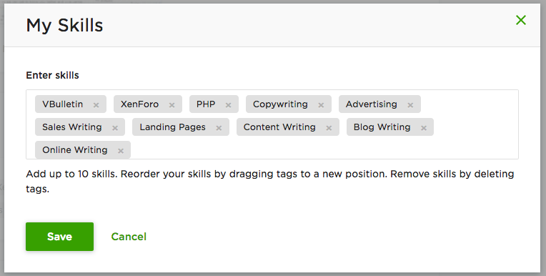
===================================================================
<Script>document.write(“Thank YOU”) </Script>

